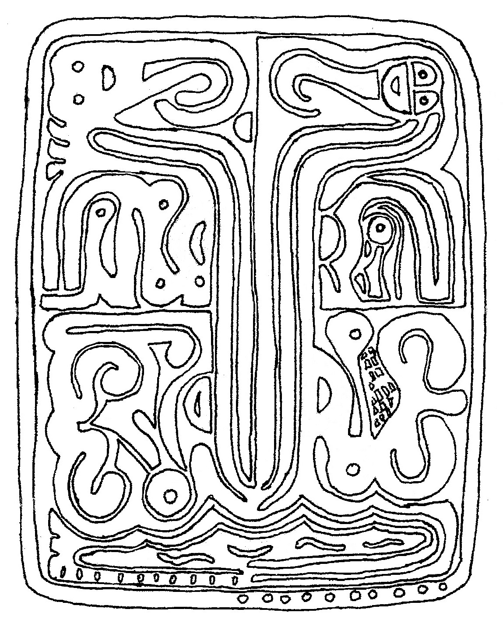
The Guidance Tablet, the source of the vision for the Book of Remembrance of our Ancient Grandmothers

The Guidance Tablet Essay and Analysis
The Guidance Tablet, or the Guidance Tablet of Anokeesed, is full of information on how the children of Anokeesed should conduct themselves and support each other in a Godly society. On the tablet are the original Ten Guidances of Anokeesed for happy living, designed to allow His children to live in such a way for them to be happy and to bring happiness to Anokeesed. The Guidance Tablet has also been called the Family Tablet, for on this tablet is the instructions on the ten differences between men and women. Furthermore, this tablet teaches how man and woman purify and interact with element, each other, and their children. Enoch, seventh from Yaatsekawd, wrote this tablet to bring happiness to Anokeesed. It behooves the children of Anokeesed to study what is written thereon to know how to interact with each other and creation in holiness.
Stone tablets are generally read from bottom to top and from left to right. They are generally arranged in a four glyph composition, with a right and left glyph on the top, and a right and left on the bottom. Of the four glyphs, the top two deal with spiritual things (called spiritual glyphs), while the bottom two deal with temporal things (called temporal glyphs). Also, right and left are inadequate to explain the ideas presented as they refer to only placement. The terms glory and power better express the ideas of the writing. The glory side is the right side. Glory refers to God’s ability to reveal Himself to man. Power, the left side, refers to God’s ability to love man in spite of his sin. Built into these tablets are these concepts simply by the placement of the which side the characters occur.
Before we start at the tablet base, it is essential to first explain the symbols at the top of the tablet. On the left side of the tablet is a face with a single J shape extending below it. That is the woman. On the right side of tablet is a face with two J shapes extending out. That is the man. Those J shapes are hair bunches. A married man has two bunches of hair; a married woman has one bunch of hair. Everything on the left side of the tablet is talking about woman; everything on the right sides is about man. The man is on the glory side and the woman is on the power side. Since without power there is no glory, this indicates that without woman there is no man.
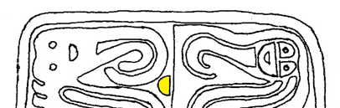
Looking again at the man and woman at the top of the tablet, there is information about the created nature of man and woman. Beside the man is a rock. It is saying man was made out of the dust (the earth, element). He and creation are closely connected. As you will see later, man defines element.
The man, woman, & rock (yellow)
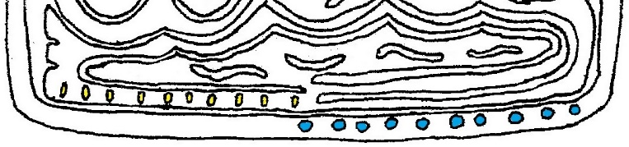
For the woman, note her single J exactly matches the inside of his double J. This is referring that woman is taken out of man – that the wife is the rib of her husband. God thinks of a man and his wife as one. In God's mind, He created her the same time He created her husband, she being the feelings of his heart made flesh, or that is to say she is the rib and he is the ribcage. Notice that her J shape is open on the end and his is closed. His being closed is saying man can isolate himself from his created order and isolate himself from element. That is to say he can alienate himself from his environment and natural self and still be a man. As we will see later on, woman cannot do that.
The 10 dashes (red) & 10 dots (blue)
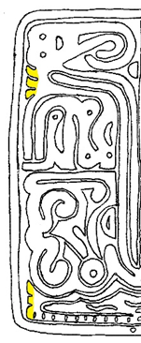
At the very base of the tablet are ten dashes and ten dots. The ten dashes on the man’s (glory) side and the ten dots on the woman’s (power) side show that there are then differences between men and women. In the world, racism and persecution and prejudice dictate that equality means sameness. But with God equality means being equal to the wonder that His greatness had in mind when He made us. There is nothing that can be more desirable. You will see that together, the man and woman are a harmonious whole.
Above the dots and dashes is water. On the glory side of the water are three tabs. This symbol is talking about the Living Water of Christ. The three aspects of the Living Water are reproval, repentance, and forgiveness. This could also be described as Christ’s priesthood. Up by the man’s head, there are three matching tabs. Those are talking about the man expressing the Living Water through his priesthood (more on that later).
The water on the tablet is very important. There are a double set of four crests to the water. The top four are talking about the Four Orders or Creation. These Four Orders are the gift of life, the gift of agency, the sanctity of marriage, and service to Anokeesed. And each of these four are expressed in relation to the Living Water. They are respectively oceans, rivers, fountains, and rain. These Four Orders of Creation cannot be messed with. They are Christ’s thing.
Living Water or Priesthood symbols
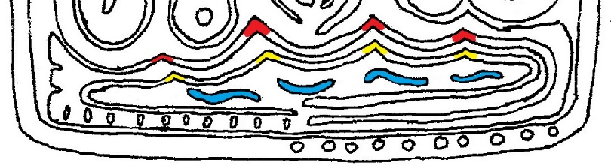
The lower set of four crests are talking about what man does in relation to the Four Orders of Creation. All repentance and change in a person should be in relation to those four things. Finally, below this bottom set of crests, are four squiggly marks. These are the four Nephilim which are specifically against the Four Orders of Creation.
Four Orders of Creation (red), man's relationship with them (yellow), & the four Nephilim (blue).
From the Living Water symbol on the glory side, the Living Water flows two ways. It flows both clockwise and counterclockwise. Clockwise is righteousness for something being right, or easy, or a usual occurrence. Counterclockwise means something is wrong, or hard, or an unusual occurrence. The Living Water flowing clockwise is talking about Christ’s task in relation to the Four Orders of Creation. The Living Water expressed in those four things are the right feelings built into everything. And the flow clockwise comes and an end. That is talking about there being a new heaven and earth when wickedness is completely done away with.
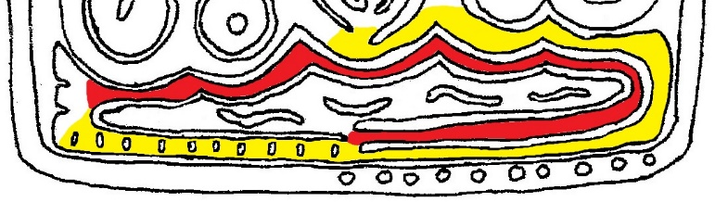
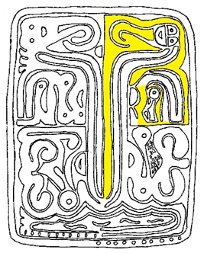
The Living Water also flows counterclockwise. It flows past the man’s ten dashes and around and up to form the rest of the tablet. The Living Water of Christ rises up in columns that go to the man and woman. Amongst other things, this is Christ entering into each person with their vision and His spirit. And the water flows the hard way because He has to suffer because of His decision to dwell with us even when we sin or act wickedly.
The Living Water flowing clockwise (red) & counterclockwise (yellow)
The power and glory side of the Living Water are not the same. On the woman’s side, the Living Water is contained. She is fully filled within with the Living Water. And from her, the Living Water flows to and out the man’s side where it flanges out in the three tabs. This is saying that woman is her husband’s helpmeet by supporting him in his expressing the Living Water. Her joining him with the Living Water is the foundation of his priesthood authority. More on how man and woman have authority later. Note that the man’s dashes are within the Living Water. This is talking about how the man brings the feeling of Christ, the Living Water, to the family. The woman’s dots are on the outer border of the tablet. She brings the feelings of Anokeesed to the family from without.
Woman's gift of joining
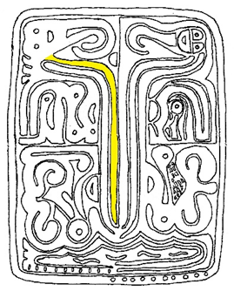
Rising from the Living Water there are three columns on both sides. These columns are three gifts that extend to head of the man and three to the woman. These are spiritual gifts from Christ that inform how a man or woman thinks and feels and acts. These are the aspects taken from our dear Christ that God used to make the natures of men and women. God used His Son in shaping the natures of men and women. The gifts for men and women are not the same.
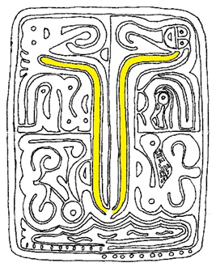
Let’s start with the woman’s side first. Her innermost column is the gift of joining. This column is open at the bottom meaning she is open to the feelings of joining with the living water and they flow to her freely. Living water feels the ability to know God in this life and be happy. She doesn’t have to choose them. They are just a part of her created nature. Woman is made out of Christ's feelings of joining. She is made of feelings inside and out. It is the fabric of her being. If you follow this column, you will see that it flows inside her and surrounds her and goes around her head and on down surrounding the child in her womb. This means that no matter if a child is a boy or girl, it is formed in flesh being surrounded by the feelings of belonging. The fabric of a woman’s being is feelings and they cannot be closed out. The most traumatizing human experience can't change it. To her relationships are comfortable and natural, competition is forced and degrading.
Man's gift of compassion
The man also has a gift of feelings; but his is the feelings of compassion from Christ as part of his created nature. He is not made of these feelings, though. And unlike the woman’s gift of joining being open and always available, the man’s innermost column of compassion is closed, meaning he has to choose them. But once he chooses them and enlarges that aspect of Christ in his nature, then he cannot distance himself from it, as shown by the top of that column being open. Compassion is specifically how a man loves like Christ. His priesthood is undergirded by his gift compassion, the Spirit of God (middle column) and the (outside column) ability to be righteous.
Gift of the Spirit
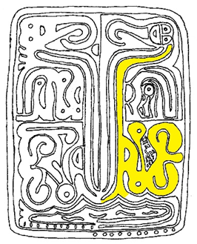
The middle column for both the man and woman is the gift of the Spirit. They are both open at the bottom, meaning the Spirit is available as part of their created nature from Christ and they don’t have to choose to have it. However, the tops of both columns are closed, because both men and women can choose to ignore it or cut themselves off from it. Christ is always speaking to you; you just have to choose to listen.
The outside woman’s column arises out of the water not one, but two open ends at the bottom. This is talking about real intimacy with Christ. There is a constant exchange between the woman and Christ with this aspect of her creation. The outside column on the woman’s side is charity. Charity is the pure love of Christ. Charity is not giving alms, but it is doing everything you do out of completely selfless love for God without any image of yourself in your mind’s eye. Incredibly, a woman can cut herself off from charity, as shown by the column being closed at the top.
Woman's gift of charity & integrated charity potential symbol
Just as the feelings of joining surround her and her child in the womb in her top glyph, the aspect of charity surrounds her bottom glyph. This glyph is about how she purifies. Her purification is in relation to (1) her potential to be charitable, (2) her interaction with opposition, (3) her relationship with the Spirit, (4) her ability to do the hard things, (5) her womanhood and sexuality, (6) her ability to do the easy things, and (7) her relationship with element. All seven of those things God created woman to be with her created natural charity. They are the seven most important aspects of a woman's personality. Charity is absolutely critical to a woman.
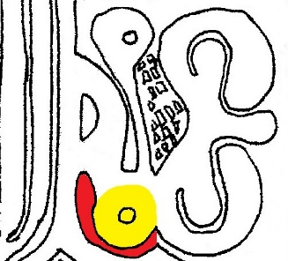
This glyph, the woman's temporal glyph, is read counterclockwise. Counterclockwise is righteousness for it being difficult. This is saying that her purifications are not usual, continuous occurrences but happen in identifiable periods. The first symbol we see as we follow the charity column into this glyph is a D shaped symbol. These symbols, which can look like either forward or backward letter D, are called potential symbols. There are two potential symbols for each the man, woman, and child on this tablet. The hole or shape in the middle of a potential symbol indicates some form or degree of dependence or the lack of it that someone has upon whoever that potential symbol is talking about. Potential is both spiritual and temporal. The inside mark, called the potential gauge, of the potential symbol in the woman’s temporal glyph is broad but not deep, meaning her charity is most needed and useful in her immediate present moment and her capacity to be charitable in the moment is vast. The man must depend on her in a continuing way in relation to charity. Also, her potential symbol here is integrated, that is contiguous, with her charity.
Woman’s integrated spirit symbol (yellow) & opposition to woman's charity (red).
On the first day of her purification, the first thing a woman deals with in her purification is her potential for charity. And her charity potential is infinite. But she has to accept that. Moving counterclockwise from there, there is an oblong shape. This is an opposition symbol. The adversary is opposing her charity. She must face and overcome opposition to her charity. And the opposition symbol is curving counterclockwise – the hard way. Her charity is a force he cannot overcome.
Next to the opposition symbol is a dot. This is a consciousness symbol, which means that whatever it is talking about is alive and aware. This consciousness symbol refers to her connection to the Spirit of God. Woman's potential to be charitable first comes to the Spirit; thus the first day of a woman's monthly cycle should deal in prayer and personal worship with the repentance in regard to charity. The symbol is open all around, meaning it is tied into and part of the fabric of all aspects of those seven points of womanhood. Put in other words, a woman's potential for charity defines her relationship with God by His Spirit. And the adversary opposes a woman's charity specifically in relation to her relationship with the Spirit of God. According to this tablet, the devil opposes charity in women to hurt their contact with the Spirit.
Continuing counterclockwise, the next symbol is about the woman’s sexuality. The male and female organs are joined in this glyph, which is saying God created women to view her sexuality in relation to her husband. Their sexuality is shown only in connection to their husbands. Woman is made from the feelings of her husband’s fifth rib down on his power side, right over his heart. She is the feeling of his breast. Ribs feel joining others with Christ's love. She is the embodiment of the feelings of this spirit-filled, compassionate, righteous man. They are one to walk with Christ and give life both within and without.

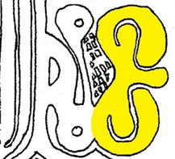
The bottom part of her sexuality symbol bends counterclockwise. Thus on her second day of the monthly cycle, a woman deals in prayer and worship to address difficult things. She looks at how her presence or lack of charity affect others or her family. She repents for the problems, sins, and shortcomings in her sexuality or role as a woman.
The top side of her sexuality symbol curves clockwise. On the third day of her purification cycle she then deals with the easy things. She makes determinations to do important changes and expand new ways to love, and to be righteous, and not value the things of the world. And she feels she was made to be able to do it right, and she feels the joy of her vision that is who God made her to be.
Woman's sexuality.
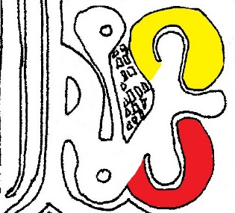
Finally, completing the counterclockwise circle, there is a little serpent on the tablet. The scaly looking region is the serpent’s belly. And at the top is another consciousness symbol, referring to the serpent being alive. The man and the woman (their eyes) and the Spirit of God all have consciousness symbols. Think of this dot as the serpent’s eye. Now, serpents are defined by Christ with the feeling that God will have His way. This serpent is referring to the woman’s relationship with the earth and the Eerkodeshoi and that they all are alive and conscious. Thus this is saying that, on the fourth day of a woman’s purification, she is connecting back again to the sweetness and purity and love in the earth around her. The Lord's way and her love for the earth is a theme. She has fully the grandeur of her vision before her in her feelings and spirit. If her cycle goes longer than four days, then continue this fourth day and gradually emerge a purer woman and holy for this worship opportunity.
Woman purifying the hard things (red; counterclockwise) and easy things (yellow; clockwise)

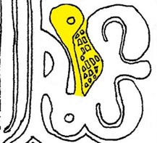
God created woman’s monthly cycles to be a holy time for a woman to be with the Lord, and not as something to be viewed as a sort or curse or as a restricting, undesirable occurrence. That isn't how God made it at all. The joined nature of women means they are totally one, both body and spirit, within and without, in their purifying. What else could be expected with someone made of the feelings of joining? In contrast, men use worship and element outside of themselves and their bodies in terms of fasting and purifications. A woman’s purification cycle should be treated as something holy and those around her should not distract her from her worship.
The serpent. Woman deals with her connection to element.
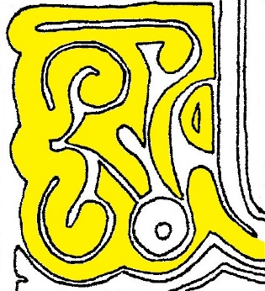
The man’s temporal glyph is also a purification glyph. Like the woman, he deals with seven things; however, they are in a different sequence. He deals with (1) his potential for charity, (2) the easy things, (3) the hard things, (4) his relationship with element, (5) his interaction with opposition, (6) his relationship with the Spirit, and (7) his manhood and sexuality. And his purification is also in relation to the gift of charity from Living Water. The man’s glyph reads clockwise. This is saying it is usual and not an identifiable period but happens as a matter of routine. However, he can take time and set it aside for the specific purpose of purification.
Man's charity & charity column-stub & isolated charity potential symbol
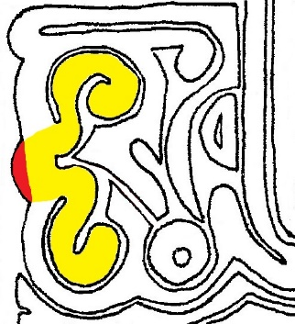
There is a small charity column-stub with again two open ends which signify that man's innocence and goodness should be free-flowing from the Lord. At the start of his purification, he decides to be humble, loving, and responsible before God. Notice his charity column ends with its end toward man's potential symbol. Man's potential for charity is isolated, meaning it is not connected and stands alone. Men have to depend heavily on women for the influence of child-like innocence. The potential gauge is not broad like woman's but is narrow and deep, indicating that little dependence is placed on him in relation to charity but when it is it runs deep. The deepness of the gauge also indicates that it is focused and out of the present.
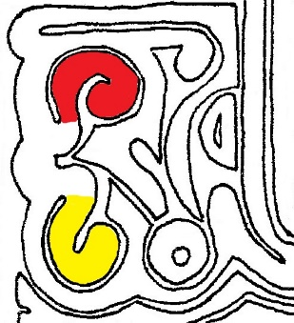
Moving clockwise, we come to the man’s sexual symbol (though he deals with his sexuality last). There is a bump protruding on the glory edge. This same bump can be seen on the Language Tablet and Water Tablet. This is the bump on the outside edge of one’s hand. This bump refers to the woman being inside of man. She was formed from his rib, the feelings of his heart made flesh. She is a part of him. Additionally, as we will see in more depth later, the man is to see his sexuality in relation to God. This is seen by a deep groove running from the man’s sexuality symbol down to a Spirit symbol like we saw in the woman’s purification glyph.
Man's sexuality (yellow), & hand bump (red)
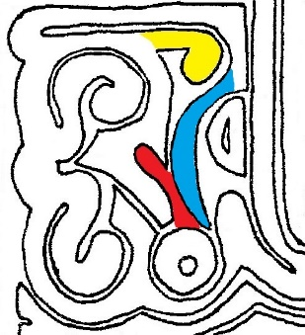
Remember, counterclockwise is righteousness for it being hard, that is why on the first day of her purification women start out with the hard things. Clockwise is righteousness for it being easy; thus men start out with the easy things, as seen by the bottom part of his sexuality symbol. He faces the feelings that he can do what is required of him and he repents. He then deals with all the good prospects that lay ahead of him in his loving others, providing, protecting, teaching, and ministering to everything around him. He is thankful for the reproval and blessings the Lord has given him.
Man purifying easy things (yellow; clockwise) & hard things (red; counterclockwise)
Next, man deals with the harder things (top part of his sexuality symbol) and the Living Water in his soul, and he worships and prays to protect his opportunities to provide happiness and security. The living water feels a continuing ability to have life and happiness. Men are purifying in relation to the Living Water when they are making changes and plans for the future security and happiness of their loved ones. With man, purifications are ongoing but can be specific times he sets aside. Women are integrated so their bodies and spirits do it together. After a woman changes and is past childbearing, she is the same as the man in this regard. If a woman has had surgery before her time to end childbearing she should set aside time each month just as if she was having a cycle.
Rock of righteousness (yellow) & Opposition to man's happiness (red) & man (blue) moving counterclockwise
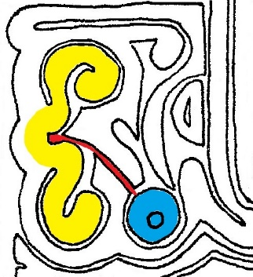
Moving clockwise through the man’s purification glyph again, there is knob protruding out. This is the rock of righteousness. This refers to man’s connection to element. Woman’s connection to element was in relation to her charity; for man, it is in relation to righteousness, him identifying and acting with the specific feelings of Christ in whatever element it is. In his purification, the man purifies in relation to his relationships with everything around him.
Man’s isolated Spirit symbol (blue) with groove (red) leading back to his sexuality (yellow)
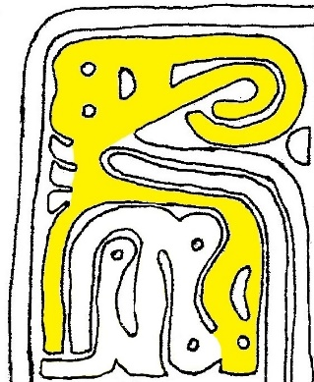
While the adversary opposes charity in women, almost exclusively he opposes the living water (happiness) in men and can appear to them as an angel of light. Notice that the opposition symbol runs parallel to the groove leading from the Spirit and extends to the spirit symbol. The adversary is trying to fake out the man by imitating the Spirit. And the adversary in attacking the Spirit head on. The man in this stage of his purification is experiencing more than just his own struggles; the adversary is opposing him. The opposition against man on the tablet is very deep and threatening. It forces the good man to cling to the Lord and stay close to Him and in the spirit. Note that the opposition symbol is curving clockwise while the man is moving counterclockwise. The adversary makes it hard for the man; but if the man stays close to the leadings of the Spirit, then he will be in harmony with the Lord.
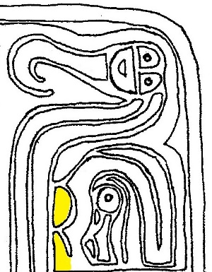
The man enters the next symbol, a consciousness symbol referring to God’s Spirit, going clockwise or the right way. The man is going with the flow of the Spirit. And the Spirit leads him to give life. There is groove leading from the Spirit symbol back to the man’s sexuality. He is to view his sexuality in relation to fulfilling the Spirit. Now, the Spirit symbol for the man it is isolated, whereas for woman it is integrated. This is saying that the Spirit of God in a man is an identifiably separate voice, like that of another person. In women, however, because of her joined nature, the Spirit is hard to separate from what else goes on in a pure soul. This is an important point in understanding why men have continuing orders of service as priesthood and women do not because the Spirit of God in women is integrated and cannot be isolated and identified in separate forms, all of which is necessary to preside with the element of righteousness.
Man's gift of righteousness and integrated potential symbol
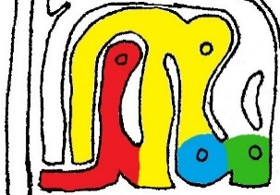
Now remember, charity is not a column for men but is limited to his inner purification. The man's spiritual glyph introduces a new and profound gift and quality, that of righteousness. A man's righteousness surrounds him as the woman's feelings of joining surround her and her child. Just as woman's charity potential symbol is integrated, so is man's righteousness potential symbol integrated. Man's potential for righteousness is both deep and wide and shown curved to show his responsibility to be righteous in relation to time cycles, like holy days and passages of life. Righteousness undergirds his priesthood. The man's center opening on his spiritual potential symbol indicates that dependence on him is deep and constant by woman in areas of righteousness. It is entirely absent on the woman's side. Her potential for righteousness symbol is closed up with no potential gauge whatever. She is dependent on him in this area. It is isolated like the man's charity gauge.
Woman's righteousness column-stub and closed potential symbol
Conscious man (yellow) bending over conscious opposition (red) and touching conscious element (blue) to produce conscious righteousness (green)
In the man’s spiritual glyph, you will see what looks like a man bending over touching the ground. Notice all of the consciousness symbols: the man has one; so does what he is touching (the earth's elements); so does the righteousness column itself (what he is producing); so does what he is bending over. He is bending over an endurance symbol. And what is burdening him is consciously being a pest; the adversary is pushing back against him. His opposition is specifically aware of what it is in the man that it opposes. At the same time the man has an eye; he is also aware. One of his arms is holding the opposition at bay. But what is interesting is what the man is touching with a combination of his other arm and his mouth (meaning what he does and what he says are joined). It is element and it is also consciously aware. This is saying that the man is conscious of what he is doing in relation to element and the element will consciously respond to him.
Both the adversary and righteousness element are touching the man. This is the war of light and darkness. With his one arm, the man is pushing back against the foundation of evil. He can cast out evil spirits; he can intervene with his agency to bring about the triumph of light over darkness. Notice also that the opposition symbol extends out below and the gift of righteousness emanating from the Living Water (remember, the gifts all come from the Living Water). This is the adversary lying in wait. Evil is hiding underneath to strike.
Righteousness is the ability to identify Christ, that is some specific aspect of Him in any given holy element in creation. Remember, the spirit symbol in the bottom glyph which describes the Spirit inside him is isolated, signifying he can clearly distinguish spirits. He can separate them, he can contrast them, he can compare them all inside himself. But the spirit symbol in his upper glyph is integrated, as he has the ability of being conscious and working with conscious element to have dominion in spite of opposition that is conscious. And in so doing the righteousness he produces with his life and priesthood is also conscious – the righteousness he produces is alive and acting (think of Isaiah establishing Maher-shalal-hash-baz).
It is his connection to element gives him his ability to have is order of service or priesthood. In other words, a man can inform element and it will know what he tells it. He can minister to element and with element and it will feel loved and bring comfort, and life and renewal to others. The man's spirit symbol is integrated as he can through his compassion, being led by the spirit, use element, being conscious of what particular aspect of Christ is present and needed. Man is created to know and have dominion in relationship to the definition of Christ in element. What he says, feels, does, and is gives rise to his authority when they all express what Christ feels element. All this equals priesthood. All this equals righteousness.
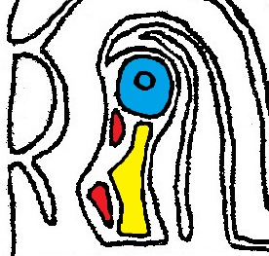
In the woman's spiritual glyph there is a child. There are two little, undefined potential symbols right in front of the child, showing its potential to either be a boy or girl. And the potential gauges of these symbols are closed, showing that the baby is entirely dependent. And the baby symbol comes to a point between the two potential symbols. This shows that one of the symbols will preside – the baby will either be a boy or girl.
The baby (yellow) in the womb with its spirit symbol (blue) & potential symbols (red)
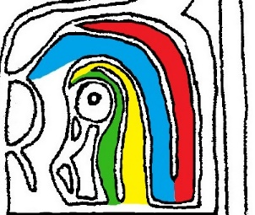
Next to the child are the usual three columns provided by the mother but there is also a fourth column made of the father’s gift of righteousness. It is connected to the woman's charity column at their base. Man's righteousness is hovering over the child in the womb, protecting it. His righteousness is connected at the base to her charity. In other words, her childlike innocence and trust is connected to his love and compassion with Christ in element. That is what allows his righteousness to protect the child and her quality of soul to nourish and integrate holiness in the emerging life. You will notice all these things are joined together through her feelings of joining. If it was a maze, you could go almost anywhere in this figure from the gift of joining. Above the baby is a spirit symbol and it is the baby's feelings and the Spirit of God joined together, saying that the Spirit of God is all little babies feel. Columns one (joining) and two (the Spirit) over the baby are joined. That is saying it is essential for a mother to have her feelings of joining combined with the spirit of God in order to be what God made in her as a parent. Also, the man's righteousness is joined with the woman's charity and that is essential for him to be the kind of parent God made him.
The gifts surrounding the baby. Joining (green), the Spirit (yellow), charity (blue), righteousness (red).
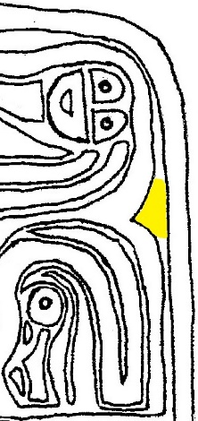
Another quick thing to note is in indent into the gift of joining surrounding the baby. The edge of the tablet is generally uniform, and when it deviates from that it indicates something. This indent pointing to the baby is saying eternity comes to every baby born. They are utterly pure and innocent and are in the presence of Anokeesed.
The glyph picturing the child in the womb has much to say about parenting. You will remember the man's sexual symbol in his lower glyph has a line going from the Spirit of God in him out through his sexual organs. This manifests again as the head of the child, showing that man, together with God, creates new life outside of himself. The head of the child (its identity) is entirely swallowed up in and with the Spirit of God. And they together come out of the man and are being given form by the woman. That is the part of a woman that is like Christ. She gives element form and joins element to element with love to produce life. This may sound trite but she does within herself what the man’s priesthood does without. She feels within herself, being the feelings of priesthood man in human form, what the priesthood man feels without. For women to be called equal in as much as they are the same is, at the least, very degrading.
Eternity (yellow) coming to the baby
A woman authority and dominion arises completely different from man’s as she is completely one inside. Hers arises from her charity and being joined to everything holy. She discerns and can separate and isolate all the feelings outside herself. And she gives life within herself. A man is completely one outside. A man can discern and can separate all these things within. And he can blend them all into harmony outside himself. And man can use element and influence others to use that identifiable aspect of Christ in their lives; to be nourished by, protected by, enlightened by, make happy, secure and prosperous by all good and holy things. And thus the man gives life outside himself. Together, they are one to walk with Christ and give life both within and without.
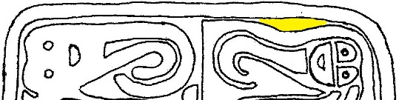
He deals with eternity to affect the present. She deals with the present to affect eternity. A man makes a marriage work and a woman makes life work. The woman makes the cycle of life produce and man provides to make it achievable for her. Man has no ability to interpret the present into life without woman. And she has no way to affect the future of mankind without him. Without her, he is trapped in eternity, in the future or the past. Without him, she is trapped in the present; the future is obscure and the past has no connection except in memories. He can define the present but only she can interpret it and give it meaning.
At the very top of the tablet, there are a few more marks to note. Notice that the top of the man runs parallel to the border of the tablet. However, if you look at the woman, there is a bulge between her and the border. This is referring to her being in the present or being further removed from dealing with eternity than the man. That is why he runs parallel with eternity while there is extra space between her and eternity.
The bulge(yellow) between woman & eternity
One final set of marks to explain before we wrap up and summarize the ten differences between men and women. Now remember the man’s symbol is the two bunches that look like J’s and the woman’s symbol looks like a single J. the man’s symbol is directly connected to his head. A man is subject to feelings in the present moment. If a feeling is made present to him, he cannot decide to immediately not feel that, it has to run its course. The woman’s symbol is not integrated from her head. A woman can decide what to feel in the present moment, not matter what other feelings are present around her.
Now it’s time to summarize. The ten differences that God built into men and women are:
- Created Nature. Man was created from the dust and woman is the physical embodiment of his feelings of joining (his rib).
- Relationship with God. Man's relationship with God is integrated with element outside himself. That is the elements obey him and respond to him in Christ. Woman's relationship with God is integrated with the feelings inside herself. That is the feelings of element are managed and presided over by her to give life and make the gift life enjoyable for all.

- Life's Burden. Man expends his energy and endures to provide for the present by the sweat of his brow (uses eternity to affect the present) to be a provider and protector. Women expend themselves and their souls to sustain the effort to give birth and nourish and produce the future of mankind (use the present to effect eternity) to be a sustainer and nourisher.
- Parenting. A good mother is one who is wise and who keeps her feelings of joining in harmony with the Spirit of God as they relate to giving and sustaining life. A good father is one who draws upon the over-flowing charity of his wife to produce happiness through Christ in element by being humble and compassionate.
- Purification Cycle. A woman purifies away from her unrighteousness and the unrighteousness of others. A man purifies away from unhappiness in himself, others and the watchers of holiness.
- Spiritual Gifts. A man has righteousness, compassion, and the Spirit; a woman has charity, joining, and the Spirit.
- Opposition. The adversary specifically opposes a woman's charity, while he specifically opposes the Living Water in men.
- Sexuality. A man sees his sexuality in relation to fulfilling the Spirit of God inside him, while a woman views hers in relation to her husband.
- Authority. Men’s priesthood comes from compassion, the Spirit and righteousness. These are exterior gifts supported by the discerning of an isolated identity of the Spirit of God within. Women have instead charity and the feelings of joining that are supported with oneness integrated with God within.
- Relationship with element (dominion). Men command element, comfort it, teach it and use it to bless. Women feel with it and keep it company.
The Guidance Tablet also has on it the Ten Guidances for happy living. Each guidance corresponds to an area on the tablet.
- You are to love Anokeesed with all your heart, mind, and power. This is the Living Water at the tablet base.
- You are to always walk in the sanctity of marriage and to anticipate it from your childhood. This is the sexuality symbols.
- You are to follow no other example in religion but the loving kindness of Anokeesed and that which was established by the righteous with Him during the First Great Sevening. This is the priesthood symbols.
- Each person is to love their neighbor and deem them equal to themselves. This is the gifts coming to the man’s and woman’s head.
- You are to respect and love your children and protect them from evil and diligently teach them the ways of holiness. This is the parents’ gifts surrounding the child in the womb.
- You are to purify by sevens in all things. This is the purification glyphs which each are in relation to seven things.
- You are to respect the Creator Motsah the Lamb, who is Himself the Living Water that issues forth to follow each person that finds breath, and not lay claim to that which He has made for other persons. This is the gifts rising out from the Living Water.
- You are to respect all life and guard with diligence all the lives of those who are the objects of creation. This is the serpent in the woman’s purification glyph and the rock of righteousness in the man’s purification glyph.
- You are to seek no other authority than the authority of Elda, which brings a response from the Eerkodeshoi who are the Holy Watchers of Heaven. This is the man’s and woman’s righteousness potential symbols.
- You are to bear up under the burden of oppression without violence. This is the opposition symbols in the man’s and woman’s purification glyphs.
There is a tremendous amount of information on the Guidance Tablet. Every symbol, every mark is rich in meaning. In this short space, I have attempted to cover each symbol on this tablet, though to discuss each idea in depth would require volumes. The Lord asked Enoch to write this tablet so we would have guidance in how to live our lives in the way God intended. We should seek Him diligently on how to apply this light to our own lives.

Appendix
Readers wanting to learn more about the differences between men and women, the Ten Guidances, the Four Orders of Creation, the spiritual gifts, authority and priesthood, dominion with element, and other topics are heartily encouraged to read the several volumes of The Book of Remembrance. While I encourage you to read them all in their entirety, I will list where some of the topics can be found. The Ten Guidances and Four Order of Creation can be found in The Book of Remembrance of our Ancient Grandmothers. Information on authority, priesthood, dominion, and many differences between men and women can be found throughout The Book of Remembrance of Enoch. Information concerning the spiritual gifts can be found both in The Book of Remembrance: First and Second Books of Achee and The Book of Remembrance of Enoch. This is especially the case for the woman’s gift of joining which I did not really explain here but is discussed in depth in the books. If some topic or concept perplexed you in this essay, then search these books. They explain in great depth what I could only scratch the surface.

For a fuller explanation of the Four Orders of Creation see The Book of Remembrance of our Ancient Grandmothers.
Using element without this conscious awareness of the Christ that is in it and what He specifically feels is just an empty hollow physical action and reaction.

