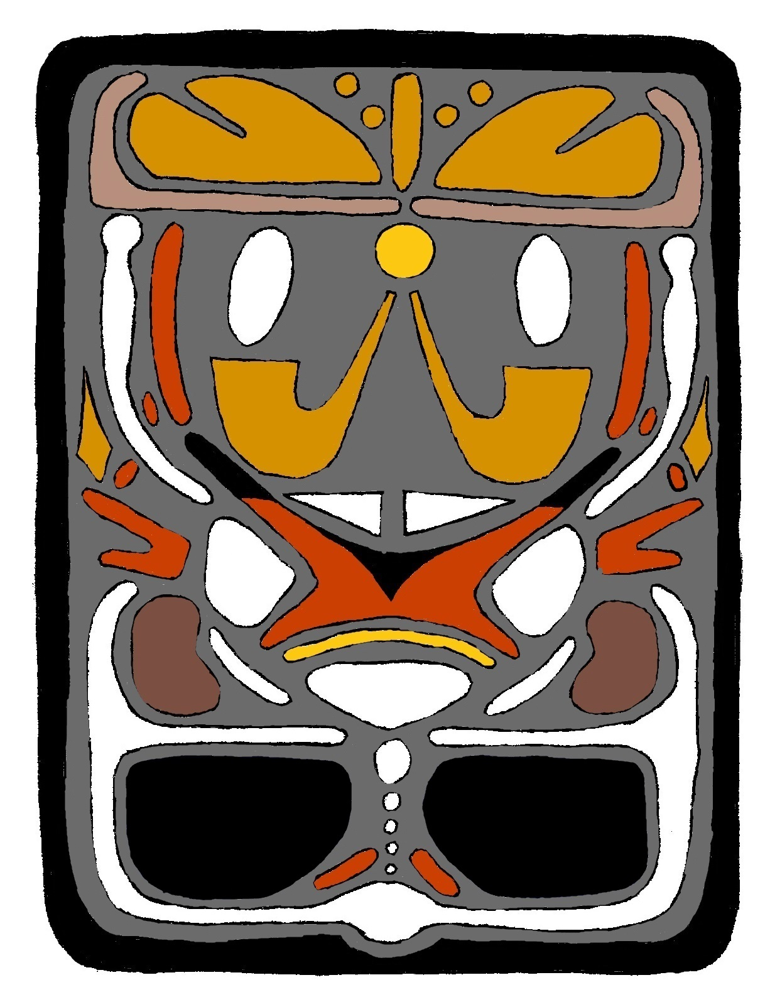
The Judgement Tablet, the source of the vision for the Book of Remembrance: The 1st and 2nd Books of Achee
Judgement Tablet Essay and Analysis
The Judgement Tablet, also called the Covenant Tablet of the Gentiles, is an advanced style tablet. It has a base and top section in addition to the usual four glyphs. It was written by Achee and preserved on a cicada. Written on it is the whole course of history from before creation till after the Final Judgement. It tells how Christ works for you and the Father’s behalf. There is a lot on this tablet, but keeping aware of how certain areas work in concert and how colors play a role in meaning can help it all stay clear.
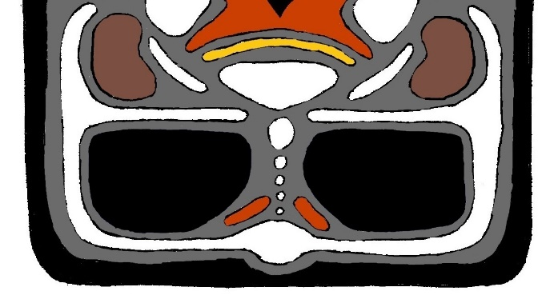
Let’s start with the base and temporal glyph of the tablet. This section of the tablet contains everything that happens before Final Judgement. The whole of human history up till Judgement is shown in the seven white dots. These are the seven dispensations of the world, each a distinct phase of human history. They have been also called the seven worlds. In ascending order on the tablet they are as follows. The first dispensation is the natural world Eden. The second is from the beginning of the temporal world till the Flood. The third is from the establishment of Shabuwa till the birth of Christ’s mother. The fourth is from the birth of Christ till wickedness coming to a fullness and the Church fleeing into the wilderness. The fifth is from the arrival of the Gentiles in the Holy Land (the Americas) till the Arm of the Lord is revealed. The sixth is the Gathering till the Second Coming of Christ. The seventh is the Millennial reign of Christ till the Final Judgement.
The base and temporal glyph showing everything before the Judgement
The size and shape of the dispensation dots are significant. Notice how the world of Eden wraps around and bugles in between the sixth and seventh worlds. This shows the return of Eden with the Second Coming of Christ. Eden also continues to bend up pointing to the Judgement indicating that the innocence of Eden is brought to bear at the Judgement by Christ. Note also how the sixth world is larger than one-through-four. This indicates the growth of the Gathering. The seventh world of the Millennium is even larger, indicating the fulfillment of holiness, etc. that the reign of Christ will bring.
With that history breakdown explained, let’s start at the base of the tablet and read what it says. The bottom white circle, in addition to being the world of Eden, shows Christ defining eternity with your personal vision of created purpose. The white areas on the tablet represent Christ’s role in His servanthood, tasks on your behalf He performed for His Father. Notice directly above this are two red bars. These indicate Christ giving His Father a reason to create specifically you on your behalf. He invented your vision of created purpose; and that vision justifies your creation. The glory side is Christ pleading for the Father to infinitely love you and the power side is to infinitely respect you. The red areas on the tablet represent Christ’s role as an advocate, the things God sees as Christ pleads on man’s behalf before Him. Note the correlation to what Christ asked and what He did in response to the Father granting it: He invented our vision as a reason to create us then He defined eternity with that reason.
This white circle stretches out in both directions and wraps around two black blocks. These blocks represent the Face of the Deep. They are black because God covered it up out of respect so as to not infringe on our gift of agency. The glory side is the presence of the Father; the power side is the presence of Christ. The white bar wrapping around them indicates Christ’s ability to surround the entire course of mankind with the presence of God (glory side) and the love of God (power side). This is another task Christ does on your behalf to enclose your personal human history and life and doings with the personal presence and love of the Father.
The Face of the Deep is dark and covered with the veil out of respect for you so that the presence of God wouldn’t overshadow your gift of agency. Note how the faces of the Deep sit on either side of the second-through-sixth worlds. In Eden, the presence of God was far more easily available. Also, note how the white bars, which spring from the world of Eden wrap back around to form a parted veil between the sixth and seventh worlds. This is the return of Eden with the Second Coming of Christ. The personal presence of Christ is bare for all to see. The Second Coming of course ushers in the seventh dispensation of the Millennium.
The white bars also continue past the return of Eden. They extend up and point towards the Judgment Bar. The innocence of Eden is brought to bear at the Judgement by Christ. More specifically, Christ brings two profound truths to you. The glory side is Christ’s ability to bring into the Judgement the reality of your truthful ability to live out your vision according to your actual life circumstances in society. The power side is Christ’s ability to bring into Judgement the reality of the truthful contact of God in your life circumstances during your walk in the flesh.
Let’s look again at the Millennium. Next to it, on each side, are white bars protruding into dark brown bean-shapes. The white bars show a third way Christ is a servant. They show Him becoming the “Word of His Power” personally for you. In other words, Christ became a Man so He could speak to you and have His Spirit reside with you in spite of sin through repentance. This is the gift of the Spirit (just like how it is a gift on the Guidance Tablet). The gift of the Spirit on the glory also is the ability of the Spirit of God to comfort following all the righteous from the temporal world into eternity. The power side is the pure love of God with His Spirit following all the righteous from the temporal world into eternity.
The brown shapes are closely intertwined with the Gift of the Spirit. Dark brown feels man being joined to family. The glory side is about your family with the Eerkodeshoi. Thus the glory Spirit gift speaks in relation to your relationship to the Eerkodeshoi. What this glory brown symbol is talking about is the Spirit bringing to you the reality of your life’s encounter with the truth in element. Now, the power brown symbol is about your relationships with all of your family of mankind. Thus the power Spirit gift speaks in relation to your relationship to people. This side is about the ability of the Spirit to bring to you the reality of your childhood and the impact of your world in society.
All of this relates to the Millennium in that it is in this station that the gift of the Spirit is fulfilled. Your relationship to the Eerkodeshoi is clear before your eyes. You deal with all of your kin and relations and the impact, either good or ill, on your family. In the Millennium you deal with all the repentance these things bring and you address all the choices and influences the temporal world wrought upon you. This is the time to fully purify in relation to your family of the Eerkodeshoi and humanity. Notice Christ’s ability to bring to you the reality of your life, and life’s circumstances, and contact with God at the Judgement bends over and protects these symbols of the Millennium. This is saying that the Millennium, and all the blessings therein, is part of Christ preparing you to stand before the Father and face your life through His eyes. One final symbol in the temporal glyph is a golden rainbow above the Millennial dot. The color gold feels the pure presence of the Father and rainbows feel the covenant. What this means is that the Lord’s promise that all men will be brought before the Father’s presence will be fulfilled at the Judgement Bar, which is directly above the golden rainbow.
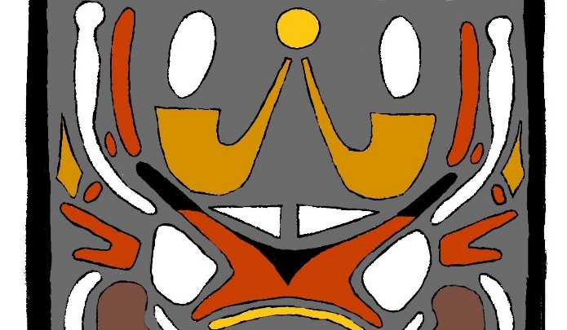
With the temporal glyph finished, let’s move up to the spiritual glyph. This glyph is about the Final Judgement and what goes on there. At the bottom center of this glyph is the Judgement Bar (in red). This is the alter where you sit at the Day of Judgement. You are seated at the black triangle in the center of the Judgement Bar. Black feels respect; and God completely respects your choices at Judgement. Your view at Judgement and your determinations establish the reality of your salvation. The tips or “horns” of the alter are also black; Christ stands on your behalf asking God to respect you fully in whatever you decided.
Spiritual glyph, showing the Judgement
The Judgement Bar is red; remember, all the red areas on this tablet have something to do with Christ’s role as an advocate for you. This one specifically is that Christ asked His Father that you could see your own life and actions through God’s eyes. Notice where you sit looks directly through the stones of Urim (in white). The bottom glory tab of the Judgement Bar shows Christ’s ability to take all of mankind into the presence of God, which thing is done at Judgement. The bottom power tab shows Christ’s ability to take all mankind into the love of God; and, at Judgement, all men will see how much God has loved them.
The Urim above the Judgement Bar is significant. With them you will see how God sees your whole life. When you are served the bread at the Judgement, you see through the glory stone of the Urim in relation to your works of righteousness. This is also when the Eerkodeshoi are asked to speak for you. You see creation of the earth in relation to God loving you. When you are served the wine, you see through the power stone of the Urim in relation to the works of your repentance. This is when mankind is asked to speak for you. You see the creation of your own spirit. The Urim, being white here, also shows an aspect of Christ’s servanthood. It indicates Christ prepared you to live with His Father (through the stations of heaven, Arm of the Lord, Millennium, etc.) exposing you to light and truth. This directly correlates with the advocacy represented with the Judgement Bar in that you will be brought before God to see your life through His eyes so Christ prepared you to be with God and see truth. It is also interesting to note that the center of the tablet falls between the two stones of Urim.

On either side of the Judgement Bar are two large white circles. These are the bread (glory side) and wine (power side) Christ serves to you at the Judgement. The bread refers to the Spirit being brought to bear in relation to all the element associated with your life; bread feels Christ is in the midst of all element so you are never alone. The wine refers to the Spirit being brought to bear in relation to your opportunities to be happy in your life; wine feels the joy of forgiveness overshadows all pain because Christ was fully obedient. The bread and wine are nestled in the sides of the Judgement Bar indicating that the Lord’s supper is an integral part of the Judgement. The bread and wine on the tablet are white. This is another task Christ performed putting in place all the mechanisms of your environment in element necessary to bring you a knowledge of your vision. He is in all things (bread) and can redeem all those who will (wine).
On the outside edge of the bread and wine are two red prongs joined together at the base. The bottom prong is the gift of feelings of compassion (glory) and joining (power); the top prong is the gift of righteousness (glory) and charity (power). Each prong also corresponds to an advocacy of Christ. The bottom prong indicates Christ asking the Father to create you in the environment (Elda) that would make you inherently good. This relates to the gift of feelings in that gift comes out of the personality of Christ Himself (see Guidance Tablet Essay). God made you in Elda surrounded by His being and feelings. The top prong indicates Christ asking His Father that you would always have the Spirit to be with you when you repented. The gift of righteousness and charity stems from you identifying and interacting with the Spirit of Christ in creation.
Directly above the gift of righteousness and charity on each side are small red dots. These indicate Christ’s advocacy in asking the Father that you could be joined with God through element by your repentance. Without this you’d be alone and couldn’t reach your vison. This advocacy correlates with Christ servanthood with the bread and wine. How he joins you with God in element is being Himself in element together with your vision and the Father. Next to these dots are dark golden flames. These represent the Spirit of God. The glory one refers to your ability to interact with the presence of God. The power one refers to your ability to interact with the Love of God.
On each side of the tablet is a long white bar rising up from the Judgement Bar. They indicate Christ performing the task becoming the definition of all human virtue. They represent the eternal nature of Christ’s righteousness (glory) and charity (power) in your behalf. They also show the growing nature of the feelings of compassion (glory) and joining (power) following you into the presence of God into eternity. The gifts from Christ that make up you emanate from Christ Himself – thus He is the definition of all human virtue. On the inside of each of these long white bars is a small red dot. This is the advocacy of Christ asking His Father that whatever decisions were made about you at the Judgement would be forever new. This directly relates to the white bars in that Christ makes your personality eternal because He, a Man, is eternal.
At the center of the top of the spiritual glyph is a bright gold dot (gold feeling the presence of God). This indicates God’s desire to live with you. It is centered over the dark golden censors and fills the Judgement with smoke, which feels His presence. The golden censors feel God’s personal worship at the Judgement. The glory censor shows God’s identity as the Father specifically in relation to your vision. The power censor shows His identity as the Father specifically in His ability to come into the flesh to save you. The smoke over the glory censor feels God’s worship of gratefulness for your vision; the smoke over the power censor is God’s worship of thankfulness for your salvation. The smoke over the censors also feels Christ’s role as Creator (glory) and Savior (power) in joining man to God and God to man in the midst of the love of the Father. On the outside of each smoke symbol is a red bar. This is the final advocacy of Christ asking that your various expressions of virtue would be seen by God to be equal to His own expressions of virtue. The glory side deals with how much God is affected eternally by you; the power side is about how much you are loved being made to be eternally new. His asking that your personal expression of virtue would be equal to God’s is responded directly by Him joining you and God together in the midst of eternity.
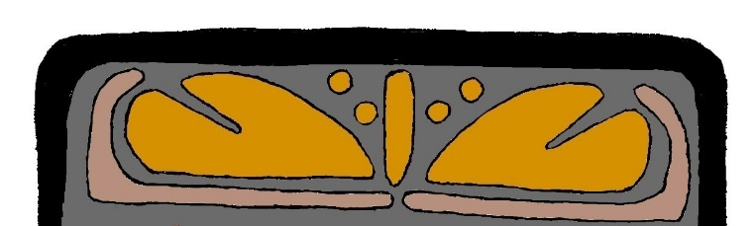
The Judgment Tablet has a top in addition to the spiritual glyph. This section of the tablet talks about what happens in eternity after the Final Judgment. There is a light brown veil at the bottom. The color is talking about separation from evil. The veil is closed and let’s in those who get to live in the presence of the Father following Judgement. The veil is used as protection and assurance to remain in His presence for absolute eternity. And on each side the veil is drawn around a shape that looks like a rock with a cleft in it. These are eternity symbols; and the veil around them shows the security one finds with God. the eternity symbols feel the haven of eternity in God’s presence (glory) and love (power). The clefts in them feel protection for you are led into God’s eternal presence and love as into a cavity of a rock.
The top of the tablet, showing after Judgement
The golden bar in the middle indicates that in absolute eternity there will always be found both power and glory. it represents the eternal nature of the distinction between power and glory in absolute eternity. On either side of this bar is a pair of dots. These are the last two advocacies of Christ; and them being here shows them to be eternal. This indicates the eternal nature of justice that came from these final advocacies.
With the tablet completely read, let’s go back and review in order the seven advocacies and the seven servanthoods of Christ. Christ’s role as an advocate are the things God sees as Christ pleads on man’s behalf before Him.
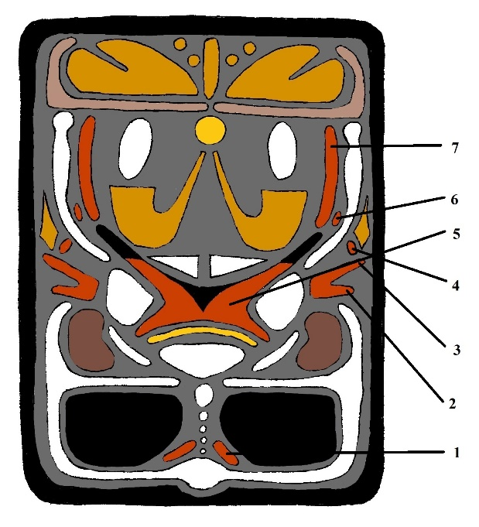
- The first is Christ gave His Father a reason to create specifically you. He invented your vision of created purpose; and that vision justifies a person’s creation. The glory side is Christ pleading for the Father to infinitely love you and the power side is to infinitely respect you.
- The second is to create you in the environment (Elda) that makes you inherently good.
- The third is that when you repented you would always have the Spirit available to you.
- The fourth is that, by your repentance, you could be joined with God through element.
- The fifth is that you could see your own life and actions through God’s eyes.
- The sixth is that whatever decisions are made about you at the Final Judgement would be forever new.
The seven advocacies of Christ (in red)
- The seventh is that your various expressions of virtue would be seen to be equal to God’s expressions of virtue.
Christ’s role in His servanthood is the seven tasks He performed on your behalf for His Father. The first three involve expressing man to God. The last four are expressing God to man.
- The first was to define eternity with your personal vision of created purpose.
- The second was to enclose your personal human history, life, and doings with the Father’s personal Presence and love (glory) and respect (power).
- The third was to become the “Word of His Power” personally for you.
- The fourth was to put in place all the mechanisms of your environment in element necessary to bring you a knowledge of your vision.
- The fifth was to prepare you to live with His Father.
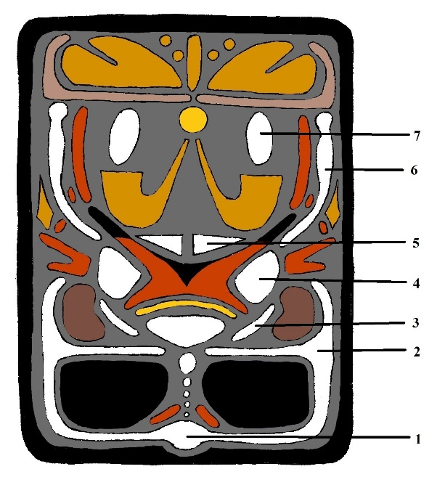
- The sixth was to become the definition of all human virtue.
- The seventh was to join man and God together completely in the midst of the love of the Father.
In the above reading we looked at some of the correlation between the advocacies and servanthoods of Christ. Each time He asked His Father something for you and God did it, Christ responded by some specific act of servanthood directly in relation to His granted request.
- First, He invented our vision as a reason to create us then He defined eternity with that reason.
- Second, He created us inherently good then enclosed our human history with the Father’s love and respect.
The seven servanthoods of Christ (in white)
- Third, if we repented we could always have the Spirit with us, then he became the Word of His Power.
- Fourth, He joined you and God in element, and He built your vision into element.
- Fifth, He allows you to see your life through God’s eyes, and He prepares you to be in God’s presence exposing you to light and truth.
- Sixth, He set that the decisions of the Judgement would be forever new, and He became the definition of human virtue making your personality eternal.
- Seventh, He asked that your personal expression of virtue would be equal to God’s, and He joined you and God together in the midst of eternity.
With that, the Judgement Tablet reading is done. Primarily it shows you the nature of Christ and His enormous love for you and the Father. It looks at the perspective of al history from the point of view of what Christ is doing. It helps you know who He is and where your place is in the grand scheme of things.

All the dark yellow symbols on the tablet have something to do with God and man being joined.
That whatever decisions made about you at the Judgement would be forever new; and that your various expressions of virtue would be seen to be equal to God’s expressions of virtue.

