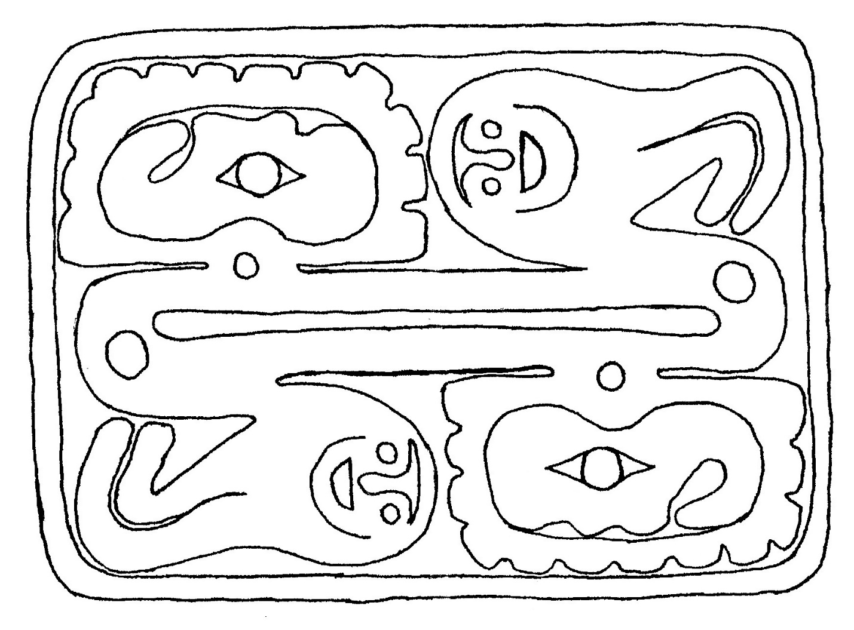
The Repentance Tablet, the source of the first part of the vision for the Book of Remembrance of Enoch

Repentance Tablet Essay and Analysis
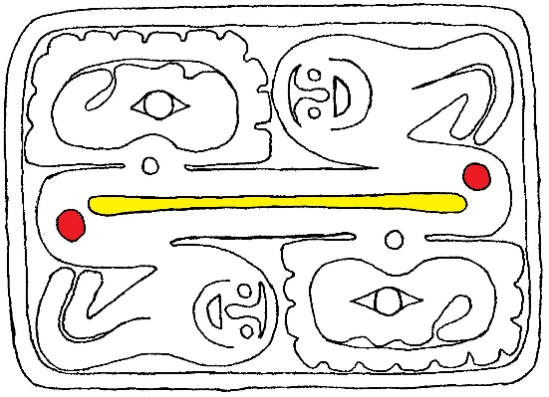
The Repentance Tablet is the very first human writing of all time. Azura found a stone covered with moss in these symbols and her husband Seth engraved them into the stone creating the first stone tablet. Another name for this tablet is the Tablet of Seth. This tablet tells how Yaatsekawd and Cavah left Eden and how they could return. Being the first tablet ever, it is very simple in its layout. There is no distinction between power and glory glyphs. The Repentance Tablet is only divided between the spiritual and temporal glyphs. Notice also how the temporal glyph is simply the spiritual glyph rotated (more on this later). This tablet is called the Repentance Tablet because it tells of the human family learning about repentance for the first time.
The veil (yellow) between the Oaks of Pethach (red)
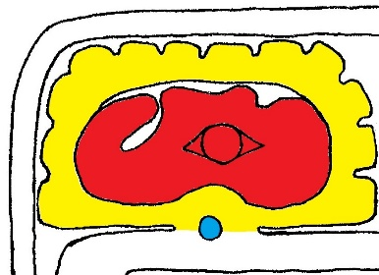
Let’s look at the center of the tablet first. There is a narrow bar dividing the middle of the tablet. That is the veil between the natural world of Eden and the temporal world. At either end is a consciousness symbol. These are the Oaks of Pethach which are the gateway to Eden. Yaatsekawd and Cavah passed between when they left Eden and when they returned. This veil separates the spiritual (about the natural world of Eden) and temporal (about the temporal world of the earth) glyphs on this tablet.
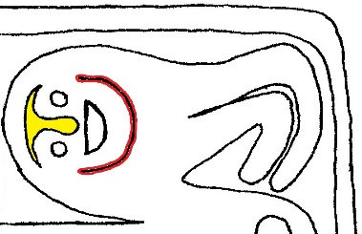
The glory side of the spiritual glyph has a tree. Inside this tree is a woman as indicated by her single bunch of hair. This is Cavah partaking of the feelings of the juniper tree in her sin. Her eye is wide open. When she sinned, it is described as her eyes were opened and she saw that the tree no longer was clothed with righteousness or shone with the Arm of the Lord. Notice that her breasts (two bumps) are shown on her. In addition to signifying this is a woman, Cavah’s sin was in denying her potential to be a mother because she felt she couldn’t be an adequate mother to her son.
Cavah (red) inside the tree (yellow) which is alive (blue)
At the base of the tree Cavah is in is a consciousness symbol. This is saying that the tree is alive and aware. The tree grieved that it was misused in this sin. Around the tree are twelve tabs. These are the twelve gifts of Jeshurun. Jeshurun on this tablet is talking about Yaatsekawd’s potetntial to be a father. He’s the very first reason for whom God made the earth. Yaatsekawd’s vision was to establish Jeshurun in the visions of twelve sons he fathered.
Mourning paint (yellow) & happy paint (red)
On the other side of the spiritual glyph is a man as indicated by his two hair bunches. This is Yaatsekawd. On his face is paint. There is mourning paint above and between his eyes; and there is happy paint around his mouth. This is talking about the grief they had when they sinned and the joy they found in their repentance and forgiveness. The column attached to his glory ear is the same as on the Guidance and Water tablets. This is the gift of righteousness. Yaatsekawd defined the vision and purpose of all the spirits of life. He knew what the correct definitions of the spirit of life in things were to be. And his task for the Lord was to safeguard those. He was the one to make sure the serpent Ahroom no longer came into his and Cavah’s dwelling because he discerned Ahroom to no longer be keeping to its original correct station. And his sin was to use the spirit of life in the juniper tree in a way for which it was not intended. Furthermore, Yaatskawd learned about repentance from the spirit of life in the lamb. And he and Cavah felt forgiveness emanate from the spirits of life in the holy elements of creation.
Now the temporal glyph of this tablet is exactly the same as the spiritual glyph if you rotated it around the veil. This is saying that Yaatsekawd and Cavah are the same people, who see and feel the same things, only now they can’t see Eden. The only difference is that they are on the other side of the veil in the temporal world. Their visions, and creation, and the Lord, who is living repentance and the bringer of forgiveness, followed after them into the temporal world through the Oaks of Pethach. And it is because of this that they, and all of their righteous children. could be restored back to Eden again.

All eyes are consciousness symbols.
See I Achee 3 and II Achee 3 for information on Jeshurun.

