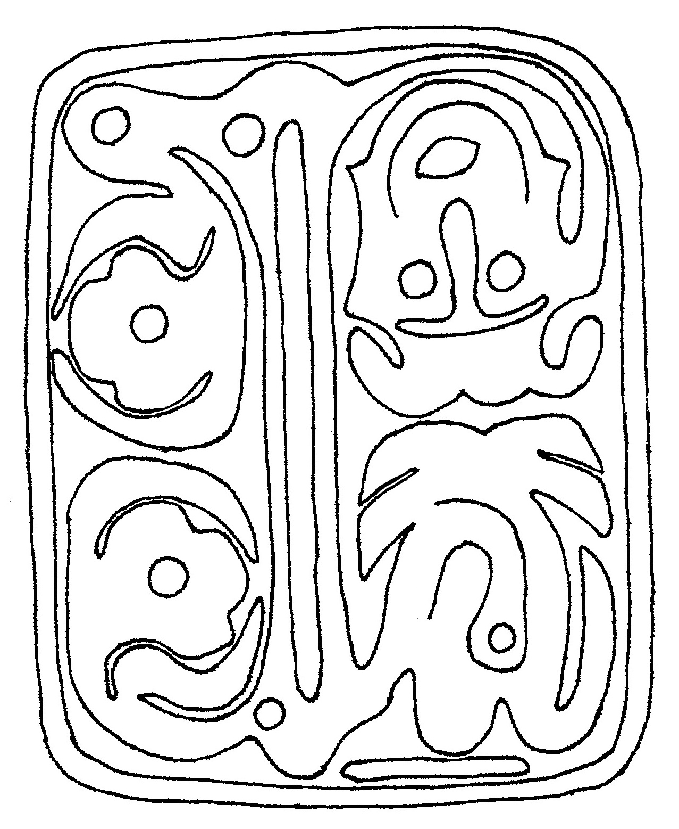
The Water Tablet, the source of the second part of the vision for the Book of Remembrance of Enoch

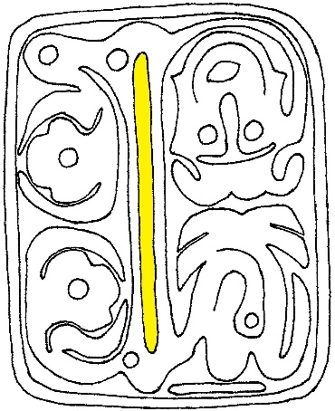
Water Tablet Essay and Analysis
The Water Tablet, also known as the Tablet of Bedal or the Tablet of Division, was written by Enoch, seventh from Yaatsekawd. Motsah the Lamb Himself etched the tablet on the ground before Enoch. The Water Tablet is used by circle drawers when they direct the weather on behalf of Motsah. The tablet also has written on it how the righteous can establish Maween, which is the ancient name for Zion. It explains how one’s pathway to virtue allows one to cross over and feel with the life that is in all things. It also shows what is the result for those who deny virtue or choose to be selective in their virtues.
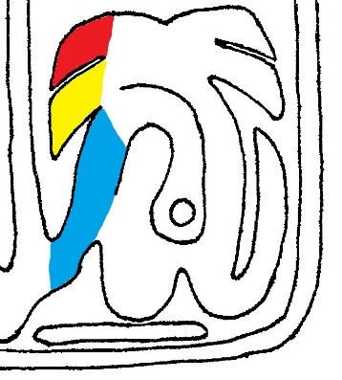
Let’s start with the temporal power glyph. Notice the tabs at the top of this glyph. These are the same gifts that are on the Guidance Tablet. On the glory side, the top one is the gift of righteousness and charity and the one below is the gift of compassion and joining. Together they are talking about a Godly person having completeness of virtue. Only walking in perfection of way and completeness of virtue will one be joined to these gifts. And the Spirit (the third gift) is heard to the degree of which completeness of virtue is attained. And the Spirit is the tab that continues down and leads you to cross over the veil. It is this walking in perfection of way, in completeness of virtue, being led by the Spirit, that takes you through the veil to be fully aware of the life that is in all things. Notice that the Spirit bends clockwise. That is righteousness for the right way.
The veil on the Division Tablet
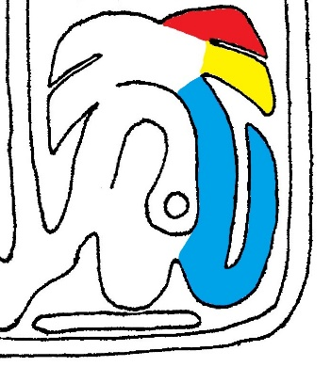
On the power side of this glyph, you will notice tabs just like the glory side only they’re facing the other way. This is talking about people who have selectiveness of virtue. Because they abandon some or all virtue, they do not have righteousness/charity and compassion/joining. When someone is selective in their virtues, then they cannot hear the Spirit to varying degrees. And those who are against the diligence of virtue are instead open to being led by false spirits, which is the third tab continuing counterclockwise (the wrong or hard way in righteousness) down to the edge of the tablet. Selectiveness of virtue and choosing to follow lying spirits will have you end void, as shown by the tab ending into nothing.
Temporal power glyph with the Godly's gifts of righteousness/ charity (red), compassion/ joining (yellow), & the Spirit (blue) which leads them past the veil.
Note that it is open both ways at the bottom here. A person who is selective in his virtues can still decide to repent and cling to all virtues even if he has followed the lying spirit to its low point before it swings around to the void. He can choose to love repentance and virtue and move clockwise (the right and easy way) to the Godly course. Conversely, someone who walks in perfection of way can still choose to abandon his virtues and move counterclockwise to end void.
Selectiveness in virtue & abandoning righteous/ charity (red), compassion/ joining (yellow), will lead you with a false spirit (blue) to end void
In the center of this glyph is an opposition symbol. In it is a consciousness symbol showing that the opposition is consciously opposing you. It is directly pointed to and opposing someone’s repentance. Note at the very base of this glyph is a long, flat bar. This is the rock of repentance upon which Godliness and being near God and His church is founded. Without loving repentance, you cannot crossover the veil.
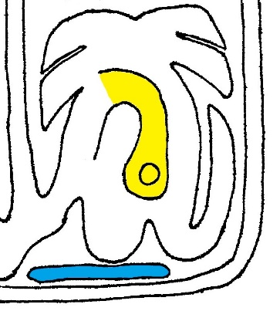
Leaving this glyph, you have made a choice: either to be complete or selective in your virtue. This choice determines where you go from here. If you have chosen to walk in perfection of way and love repentance, the Spirit will lead you the right (clockwise) way past the veil. The veil is the long bar dividing the tablet up the middle. The veil is the separation between you and Eden and being aware of the life that is in all things. If you go around the veil the right way, there is a consciousness symbol. This is the spirit of life; you are made aware of the life that is in everything by being diligent in your completeness of virtue.
Rock of repentance (blue) and opposition (yellow) consciously attacking love for repentance
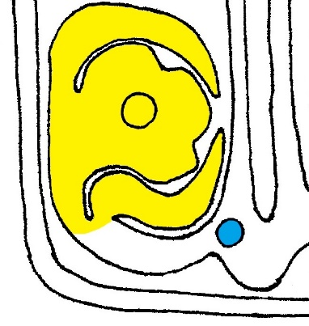
From here, you continue clockwise to a Nahookis flower, which is Maween. Maween here is turned towards her loved ones with her leaves, which feel the gathering, open to gather you in. Notice that there is a consciousness symbol in Maween. This says Maween is a living, conscious soul, like the rest of the Eerkodeshoi, who sees and responds to how you live your life. Maween will turn towards the righteous, those founded on the rock of repentance, and those among them who are struggling to love. And she will gather them in and influence them towards walking in perfection of way and completeness of virtue.
Going the right (clockwise) way around the veil brings you to awareness of the spirit of life (blue) and Maween (yellow) is turned towards you
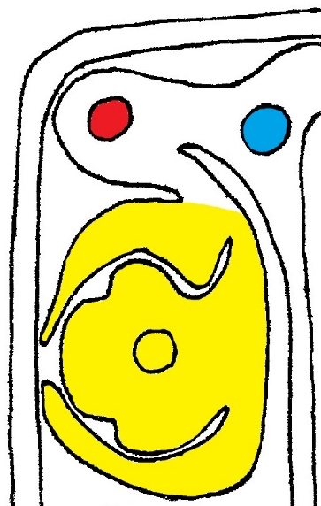
The Nahookis flower has three petals. These stand for the three names of God; starting at the top and moving clockwise they are Kahee, Anokeesed, and Motsah. This is the order of the Power of Godliness. The Godly, who love repentance and virtue, go the right way (clockwise) around the flower. And this order of the Spirit Kahee, the Father Anokeesed, and the Son Motsah is the created way to know the Lord and to love one another. For the Godly must follow the leading of the Spirit Kahee. And the Holy Spirit leads them to know Anokeesed, who is the loving kindness which is the substance of all things. And that loving kindness beckons them to come to know Motsah the Lamb in humility and repentance so that the Spirit may be restored and maintained once again for them when they repent.
But if you do not love repentance, and if you are against the diligence of virtue being selective in them, then you will go around the veil the wrong (counterclockwise) way and not pass through it. The first thing you are confronted with the wrong way around is a consciousness symbol. This one is saying you have to make another conscious choice to go the wrong way. If you choose to continue the wrong way, you come to another consciousness symbol. This is the spirit of lies. This is saying you will be taken in by lies if you choose to proceed the wrong and not repent and cling to all virtue. Continuing the wrong way culminates in Maween being turned away from you. Maween will turn away from all those who are against diligence in the diligence of virtue and perfection of way.
If you consciously choose (blue) the wrong way, then you’ll be taken in by the spirit of lies (red) and Maween (yellow) will turn away from you.
Also, because the ungodly cut themselves off from the Spirit, they cannot know God in the same order as the Godly. They have to start with Motsah, who calls them to repentance. Starting from the top, moving counter-clockwise, the names of God on the petals appear Motsah, Anokeesed, and Kahee. This order is because if they do heed the voice of Motsah, He’ll return them to Anokeesed and their flow of the Spirit will be restored.
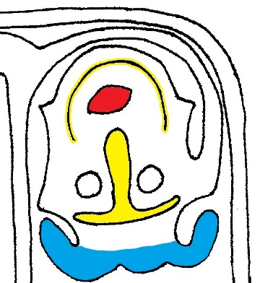
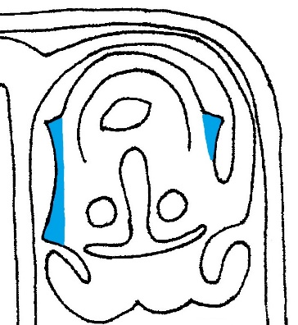
With that, let’s look at the final glyph on this tablet, the spiritual power glyph. While it is upside down, this glyph has a man’s face on it. It is a man, and not a woman, because of his two bunches of hair sticking out either side of the top of his head. The curious bump between his two hair bunches is reflective a certain hair style that a married man wears to feel that he is fully joined with his wife before God. His eyes are consciousness symbols showing he is alive and aware. He also has mourning paint (between his eyes) and happy paint (around his mouth) on his face like on the Repentance Tablet. This face paint feels that he is engaged in the process of repentance and forgiveness. His mouth is open in singing, which indicates he is a righteous man. On his ears on the side of his head are sea shells. This is to help he can hear the Living Water, which is Motsah. On the Guidance Tablet, the gift of righteousness comes up and is connected to the man’s glory ear. On the Water Tablet the same feeling of righteousness is attached to the man’s glory ear. This is saying that this holy man is engaged with the holy purposes and definitions of life found in the holy elements of creation.
The man's singing mouth (red), face paint (yellow), & hair (blue)
The shells on the man's ears
The Water Tablet explains how to establish the holy society of Maween. The rich light the Lord has brought from this tablet, in the Book of Remembrance of Enoch, is valuable in telling the children of God how they must order their lives to know Him and love each other. The interpretation by Urim of this tablet goes into far greater depth and detail than the explanation given here. But by loving repentance, clinging to virtue, and following the leading of the Spirit, you can be brought to know God in a deeper way.

Please refer to the Guidance Tablet essay for an explanation of the man’s and woman’s gifts.
See Bedal 9:28-75
See Seth 5:21-29 & 54-63
This bump also represents the bump on the outside edge of the hand which feels that your other half is a part of you. This same bump can be found on the Guidance Tablet and Language Tablet.

